**Write a program in assembly language to perform subtraction of 8-bit data.**

**CODE**  
  
**org 100h**

**num1 db 20h**

**num2 db 10h**

**start:**

**mov al, num1**

**sub al, num2**

**mov ah, 0**

**add al, 30h**

**mov dl, al**

**mov ah, 02h**

**int 21h**

**mov ah, 4Ch**

**int 21h**

**end start**

**OUTPUT** 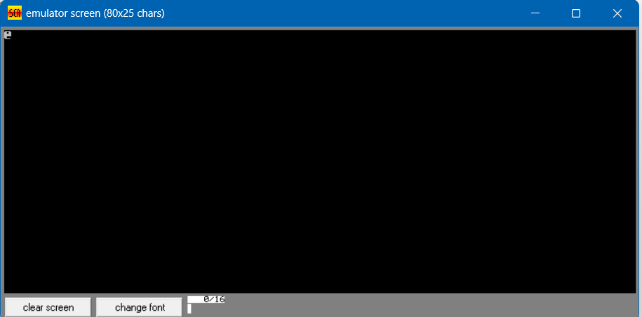

**2. Write an assembly language program to perform subtraction of 16-bit data.**

**CODE**  
  
org 100h

num1 dw 1234h

num2 dw 5678h

start:

mov ax, num1

sub ax, num2

mov bl, ah

mov bh, al

mov ah, bl

shr ah, 4

add ah, 30h

cmp ah, 39h

jle print_high

add ah, 7

print_high:

mov dl, ah

mov ah, 02h

int 21h

mov ah, bh

and ah, 0Fh

add ah, 30h

cmp ah, 39h

jle print_low

add ah, 7

print_low:

mov dl, ah

mov ah, 02h

int 21h

mov ah, 4Ch

int 21h

end start  
  
**OUTPUT**  
